SIMCOM 2023

Registration for Simcom is open! The link below is your key to the action.
We hope to see you in Green Bay

https://wi.webeocasp.com/wi/

WebEOC Access
WebEOC will be employed during SIMCOM 2023. Users will utilize their own WebEOC login information to access the page. For those planning an active role, please follow the link below to gain access to the SIMCOM 2023 page prior to the event.
https://wi.webeocasp.com/wi/
The WebEOC path is: Position: SIMCOM; Incident: 2023-05-04 May Exercise
You must have an active WebEOC account

Wednesday, May 3, 2023 – General Session & Training (Day 1)
0715 – IAP/Division Supervisors/COML Meeting (Event/Exercise Staff)
0800-0900 – Day 1 Registration
0900-1200 – SIMCOM 2023 General Session (Phoenix Room - UW - Green Bay)
- Located at the University Union, 2430 Campus Ct, Green Bay, WI 54311)
1200-1300 – Lunch (On your own)
1300-1630 – Platform Set-up and Self-Guided tours of platforms
1630 – Daily AAR (Staff only)
- Location: Phoenix Room
1800 – No-Host Social: Anduzzi's Sports Club - Green Bay East (900 Kepler Dr, Green Bay, WI 54311)
1830 – COMU Meeting (COMC/COML/COMT/INTD & Trainees) at No-Host Social
1
Phoenix Room - UW - Green Bay
Located at the University Union, 2430 Campus Ct, Green Bay, WI 54311
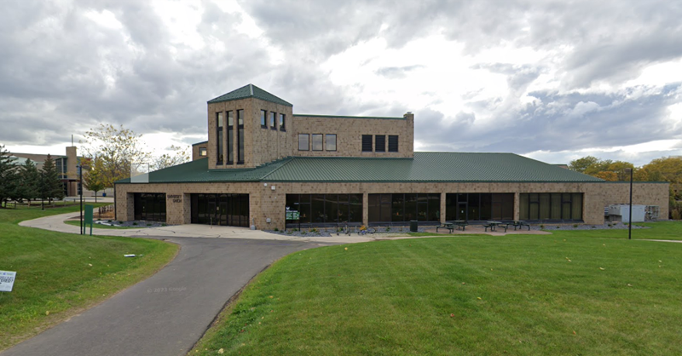
2
Parking for Phoenix Room Theater
(large mobile communications units, please park in the Baird Foundation Lots off Leon Bond Drive)
Thursday May 4, 2023 – Exercise – Day 2 (UW-GB & Eau Claire County)
0600 – Planners Arrive (IMT/COMC/COML)
Meet inside Kress Events Center (UW-GB Campus: 2358 Leon Bond Dr, Green Bay, WI 54311) https://earth.google.com/earth/d/1XlRznZPwvxduPdzvPoQjCFANOA72PgUs?usp=sharing

0600 – Event Staff Meeting (IMT/COMC/COML/Planners)

0600 – 0615 – SIMCOM IAP / Briefing
All Division Supervisors/COML/COML(t) required to attend.
Led by IC/COMC

0630 – Mobile Platforms check-in/stage at NW Parking Lot (see map) and directed to Division locations
All Participants must check-in (Division Supervisors ensure this is accomplished)
UW-GB Map Link: https://earth.google.com/earth/d/1XlRznZPwvxduPdzvPoQjCFANOA72PgUs?usp=sharing
Eau Claire Expo Center Map Link: https://goo.gl/maps/RfnGBh88mdoW3UkY9

0800 – SIMCOM IAP / Briefing to Divisions/Participants
Conducted at Division Sites based off of Division Plan
Led by Division Supervisors

0850 – Weather Briefing
Led by 126th ACS Weather Flight

0900 – START OF EXERCISE

1000 – VIP Briefing (meet inside Kress Events Center (UW-GB Campus: 2358 Leon Bond Dr, Green Bay, WI 54311)
Check in at UW-GB Kress Event Center
Facilitated by IC, WEM & WING

1000 – VIP Tour Begins, site visit to each Division Location via carpool
Division Supervisors/COML facilitate at Divisions

1130 – 1230 Lunch (Working Lunch)

1200 – VIP Tour Ends

1200 – Weather Briefing

1500 – END OF EXERCISE
All Participants must check-out (Division Supervisors ensure this is accomplished)

1545 – After Action Review (AAR)
Utilize/Submit WEM Participant Feedback Form prior to departure

1800 – No-Host Social: Anduzzi's Sports Club - Green Bay East (900 Kepler Dr, Green Bay, WI 54311)

Friday May 5, 2023 – Exercise Day 3 (UW-GB & Eau Claire County)
0600 – Planners Arrive (IMT/COMC/COML)
Meet inside Kress Events Center (UW-GB Campus: 2358 Leon Bond Dr, Green Bay, WI 54311) 54311(https://earth.google.com/earth/d/1r0V5YjRMzWSfdK_-0fRB4EGWC0cvoX7Z?usp=sharing)
0600 - Event Staff Meeting (IMT/COMC/COML/Planners)
0600 – 0615 – SIMCOM IAP / Briefing
- All Division Supervisors/COML/COML(t) required to attend
- Led by IC/COMC
0630 – Mobile Platforms check-in. Division Locations will be assigned
- All Participants must check-in (Division Supervisors ensure this is accomplished)
- UW-GB Map Link: https://earth.google.com/earth/d/1XlRznZPwvxduPdzvPoQjCFANOA72PgUs?usp=sharing
- Eau Claire Expo Center Map Link: https://goo.gl/maps/RfnGBh88mdoW3UkY9
0800 – SIMCOM IAP / Briefing to Divisions/Participants
- Conducted at Division Sites based off of Division Plan
- Led by Division Supervisors
0850 – Weather Briefing
- Led by 126th ACS Weather Flight
0900 – START OF EXERCISE
1130 – 1230 Lunch (Working Lunch)
1400 – END OF EXERCISE
- All Participants must check-out (Branch Directors ensure this is accomplished)
1445 – After Action Review (AAR)
- Utilize/Submit WEM Participant Feedback Form prior to departure

